Christmas traditions in Spain

Dia de los tres Reyes

Epiphany celebrates when the kings or wise men brought gifts to the baby Jesus.

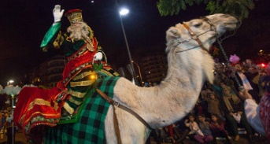

***Date:5 de enero***